HOMONYMS

Match the meanings with the words, every word has two meanings.

WORD | FIRST MEANING |  | SECOND MEANING
Mole | 1 |  | 1 | 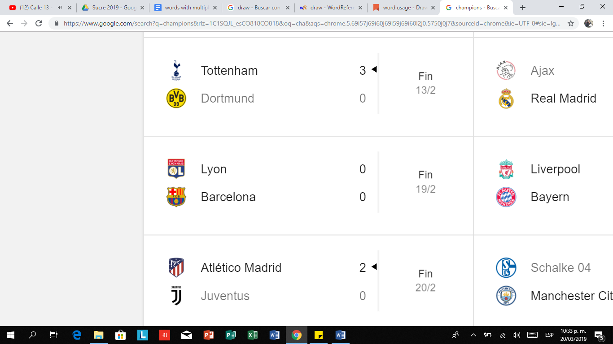
Trunk | 2 | 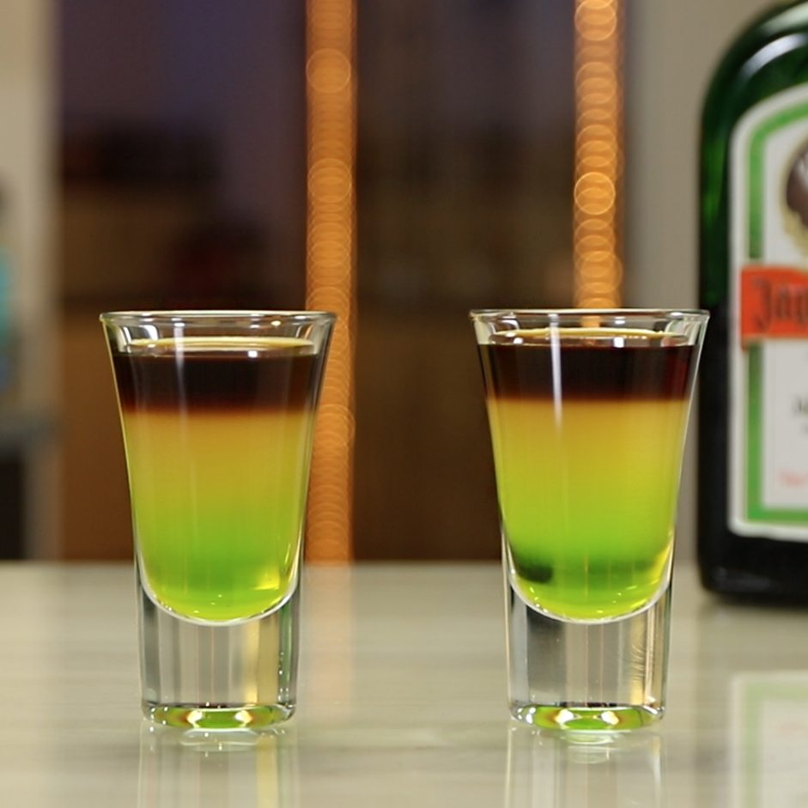 | 2 | 
Bark | 3 |  | 3 | 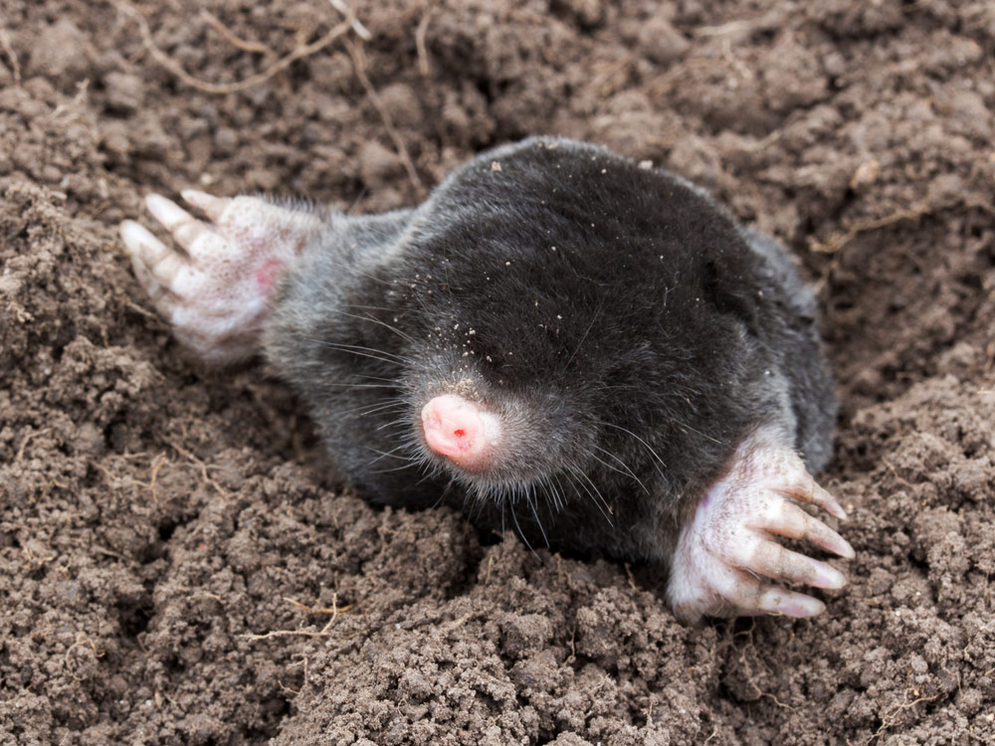
Shot | 4 |  | 4 | 
Fire | 5 |  | 5 | 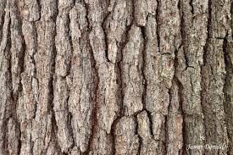
Tie | 6 |  | 6 | 
Match | 7 |  | 7 | 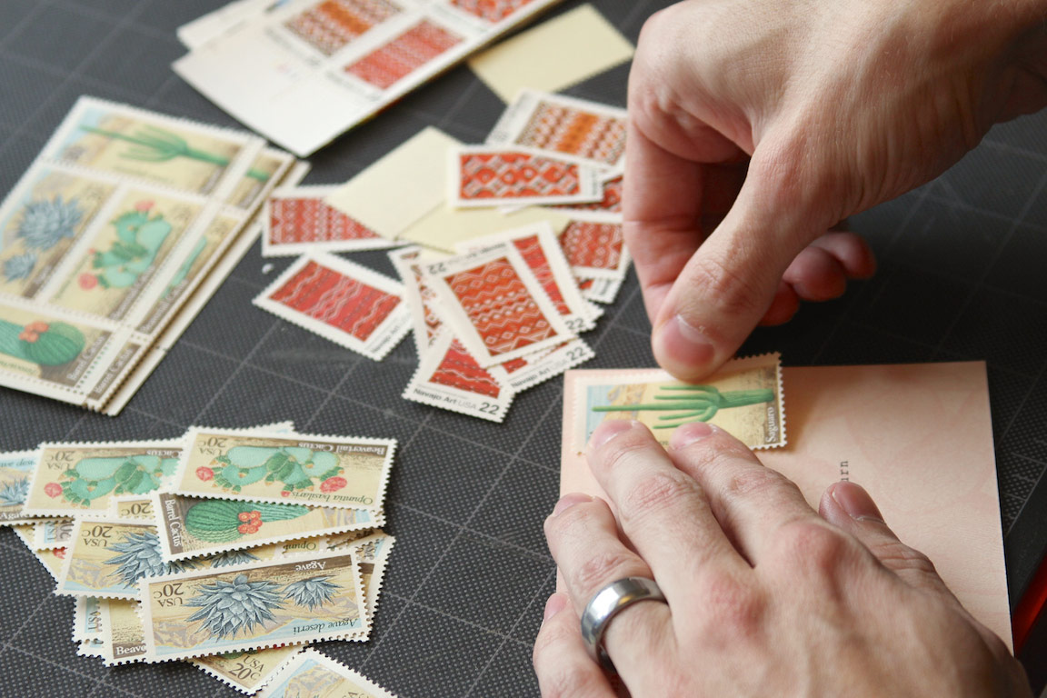
Stick | 8 |  | 8 | 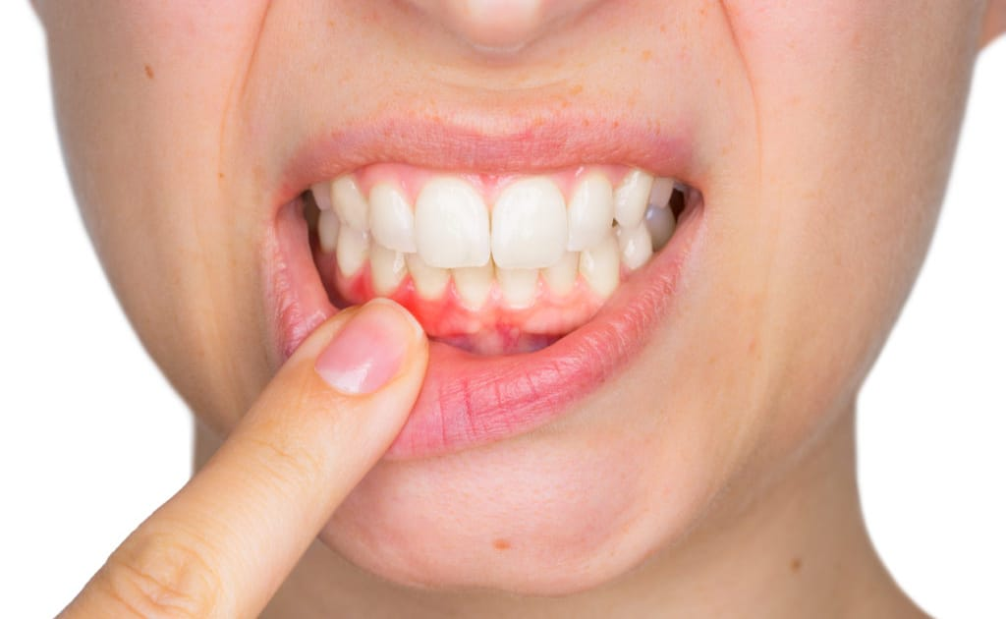
Tap | 9 | 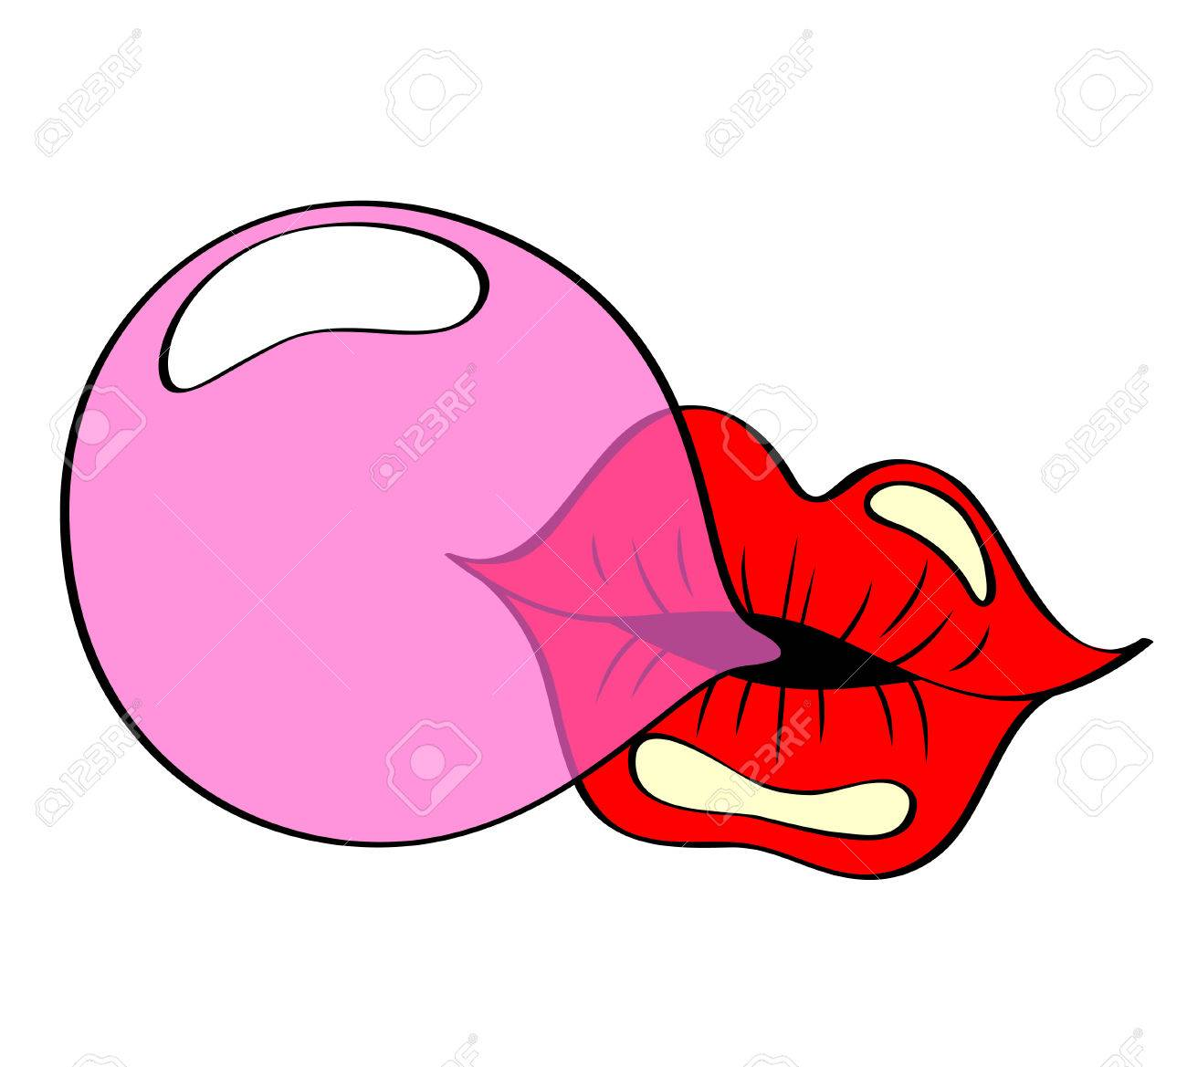 | 9 | 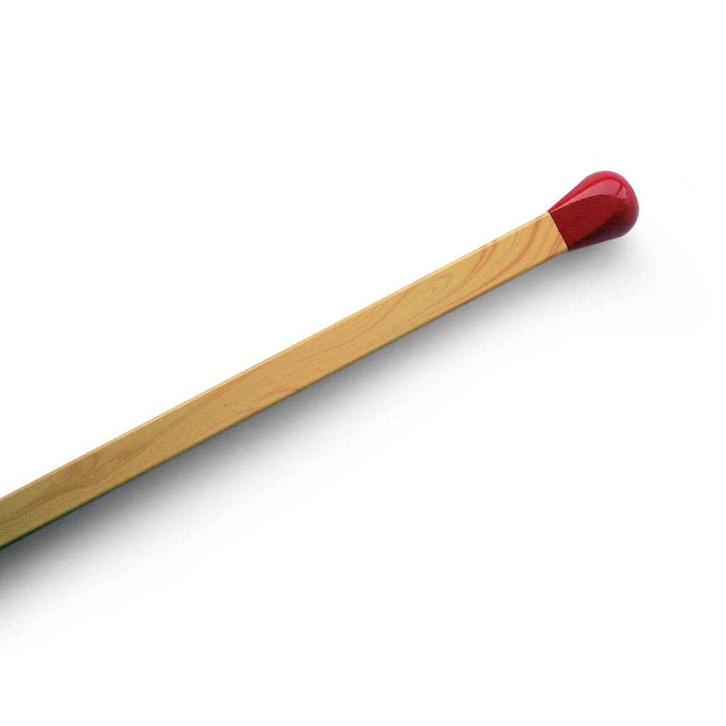
Gum | 10 | 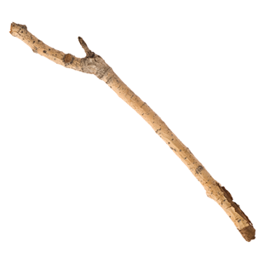 | 10 | 

HOMOGRAPHS

Practice the correct pronunciation of the following sentences, every word that is highlighted has a different pronunciation

- The doctor wound the wound
- The farm was used to produce produce
- We must polish the Polish furniture
- He decided to desert his dessert in the desert
- A bass was painted on the bass drum
- The dove dove into the bushes
- The buck does funny things when does are present
- A sewer fell into a sewer line
- After a number of injections my jaw got number
- When he saw the tear on the painting he shed a tear
- I did not object to the object
- I had to subject the subject to a series of tests
- Since there was no time like the present, he thought it was time to present the present.

